MEMO

**To:** Traci Gardner

**From:** Student Names Removed to Protect Privacy

**Date:** 7 April 2023

**Subject:** Subject for Recommendation Report: Food Insecurity at Virginia Tech

As college students, eating food and having accessibility to food at all times is a very important factor in our ability to perform our best academically. Food is fuel, and of course, a necessity, so it should be a top priority within the university to make it as easily attainable as possible.

Students can spend full days on campus, from morning to night, and therefore they rely fully on one or more of the 11 different on-campus dining halls to provide their meals. The main problem, however, is the pricing of on-campus dining.

If a student does not have a meal plan, purchasing food on campus can be outrageously expensive. VT meal plans do offer a “flex” plan, where 50% of the total is discounted, making the price of the meal much less expensive.

However, many students who live off campus do not purchase dining plans, which in most cases makes eating on campus too expensive for most to afford. For example, the price of a regular cheeseburger and a basket of fries at West End’s Fighting Gobbler is a total of $15.80 without a meal plan. If someone without a meal plan wants a plain coffee and a bagel sandwich from ABP, that would amount to $9.38. The prices of food on campus are entirely too expensive for a college student to be able to reasonably afford.

For our recommendation report in this course, we want to study the feasibility of lowering the cost of on campus food and make it more accessible and affordable for off-campus students who do not purchase a meal plan.

# Overview and Rationale

The subject of our report is food affordability and accessibility on the Virginia Tech campus. Food insecurity has and continues to be an issue that plagues many college campuses. At Virginia Tech, it manifests itself in the form of affordability. Despite attempts to make food more affordable with food pantries, those pantries require more effort to access than a dining hall and are not widely advertised. Instead, students have little to no other options than to buy dining hall food. This is realistically unaffordable.

College is already expensive. In the 2021-22 school year, each dining plan was raised by hundreds of dollars per plan to help fund wages for the dining hall employees. The cost of food items also increased, though the amount of food did not. While these employees deserve a fair wage, is it the best idea to significantly increase the dining plans of on-campus students? In the

past 10 years, Virginia Tech has raised its tuition by 31.52%, 2.66% more than the state average. Schools have been able to raise their tuition without buyer resistance because of the government's increasing generosity with student loans. This report intends to investigate how funds could be adjusted to better aid food insecure students.

Dining hall prices do not affect only those with lower incomes. In fact, most low income students can’t even afford a meal plan. Students from all socioeconomic backgrounds struggle to budget their dining plans without running out of money by the end of the semester. The dining plans are advertised to last through the semester, but most supply only enough money for students to eat 10-14 meals in a week. Subsequently, this can lead to students skipping meals in order to avoid having to deposit additional funds into their meal plan. The overpricing of on-campus food has negatively impacted students mentally, financially, and physically.

The purpose of our report is to bring the issues of food insecurity and affordability at Virginia Tech to light, and to propose solutions that will help alleviate financial burdens for all students. Our report will include surveys taken by the student body on food insecurity, as well as the statistics surrounding increasing costs of attending public university. These issues are immediate and pressing. Food insecurity already affects around 30% of four-year college students nationally, and that number continues to grow as food becomes more expensive.

Why does this matter? Food and nutrition affects academic performance. A 2014 study at two Maryland community colleges showed that students who are food insecure are more likely to report a significantly lower GPA than students who can afford food.1 The food that they can afford is typically processed and low in nutritional value, which increases those students' risk of detrimental health difficulties in their future. By not providing all students with affordable food options, universities are putting students at risk of academic failure and physical complications.

# Methodology/Resources

In addition to conducting online research into the overall issue of food affordability, we will conduct surveys designed to gain information about what others think about the pricing of

on-campus food, whether they eat on campus or cannot afford to, and other questions related to our subject . We will be sending the surveys through email. We plan on creating a visual representation of the data we collect from these surveys.

We will also be looking into the library archives to collect information on how and why Dining Services has changed prices over the years. In addition to conducting online research into the overall issue of food affordability, we will conduct surveys designed to gain information about what others think about the pricing of on-campus food, whether they eat on campus or cannot afford to, and other questions related to our subject. We will be sending the surveys through email. We plan on creating a visual representation of the data we collect from these surveys.

We will also be looking into the library archives to collect information on how and why Dining Services has changed prices over the years.

# Audience

We hope to share our research findings and proposal with the Dining Services of VT. Bringing our report directly to Dining Services will ensure direct and efficient transfer of information and hopefully result in immediate action to resolve the problem.

# Personnel

Student 1 is a Junior studying English with a minor in literature studies. Allie is fortunate enough to have a dining plan and often eats on campus, however, she is very aware of the issues that come along with food accessibility at VT and feels passionate about working towards a solution.

Student 2 is a freshman double majoring in Creative Writing and Professional and Technical Writing. She is minoring in Real Estate. Lillie has formerly researched food insecurity at universities during a previous leadership class, and is passionate about finding solutions to food accessibility and affordability issues.

Student 3 is a senior at Virginia Tech and is majoring in Agriculture Business with a minor in management. He recently took a class that was focused on food insecurity in the New River valley and it helped give him a better understanding of the topic. Ben will be graduating this May and will be starting a summer internship with John Deere.

# Timetable

As a group, we will first focus on the body of the Research Proposal before working on the aesthetics. This will ensure enough time for the body of work to be written and edited before the deadline; optional components will be completed if time permits.

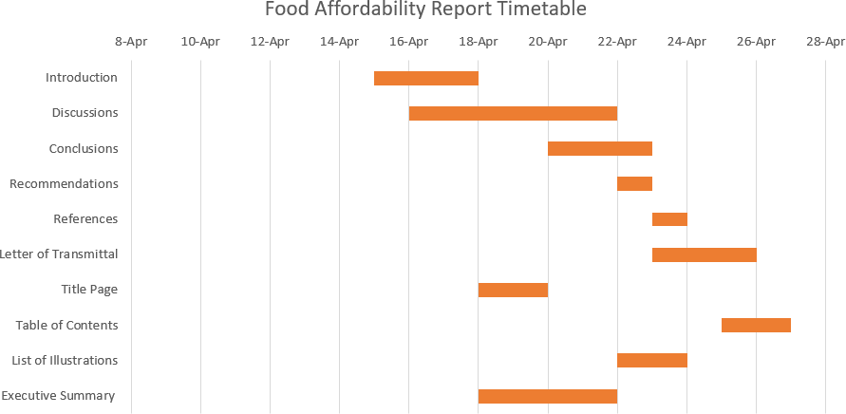

4

# Conclusion

Food insecurity and affordability continues to be an issue for students at Virginia Tech. Students can’t afford to eat three meals a day with the dining plans provided, and students without dining plans struggle to afford dining hall food at the price they are sold for. While there are food pantries in Blacksburg, they are not well-advertised. Most food pantries are off- campus and require planning and transportation to reach. The price of dining on campus is difficult to meet on top of tuition and other fees.

In order for students to be successful in their academic and personal lives, they need to be well-fueled with nutrient rich and accessible food. As of today, this has been a struggle for many universities to achieve. Our goal is to research solutions to provide students equal access to affordable and quality food. This could be achieved through lowering food and dining plan prices, and creating more accessible food options for low income students.

For any questions regarding this report, please contact Student 1 at [email@vt.edu](mailto:email@vt.edu) or 123-456-7890.